EXPT NO: 5 | IMPLEMENTATION OF A RECURRENT NEURAL NETWORK (RNN) FOR TEXT GENERATION
DATE:

PRE-LAB QUESTIONS (PROVIDE BRIEF ANSWERS TO THE FOLLOWING QUESTIONS)
1. Explain the purpose of a Recurrent Neural Network (RNN) in processing sequential data.
An RNN processes sequential data by remembering information from previous steps. It helps to understand the relationship between elements in a sequence.

2. Why is an RNN considered an appropriate model for text generation tasks?
An RNN is suitable for text generation because text is sequential. It uses previous words to predict the next word.

3. Describe the concept of sequence modeling in Natural Language Processing.
Sequence modeling is the process of learning the order and relationships between words in a sequence to understand and predict text.

4. Explain the importance of tokenization during text preprocessing for RNN-based text generation.
Tokenization divides text into individual words or tokens. It makes the text easier to process and convert into numerical values.

5. Explain the significance of converting text into numerical representations before training an RNN.
RNNs cannot directly process text. Therefore, words are converted into numerical values
so that the model can learn patterns from the text.

AIM
To implement a Recurrent Neural Network (RNN) for text generation and evaluate its ability to generate meaningful text by predicting the next word in a sequence.

SOFTWARE REQUIREMENTS
- Python
- TensorFlow or keras or PyTorch
- Google Colab
- GitHub
- Numpy
- Matplotlib

PROCEDURE
TASK A: DATASET PREPARATION
Perform the following tasks:
- Load the Tiny Shakespeare dataset from Hugging Face.
- Explore the dataset and examine the text samples.
- Convert the text into lowercase (if required).
- Tokenize the text into individual words.
- Build a vocabulary and assign a unique integer index to each word.
- Generate input sequences for next-word prediction.
- Apply sequence padding to obtain inputs of equal length.
- Split the prepared sequences into training and validation datasets.

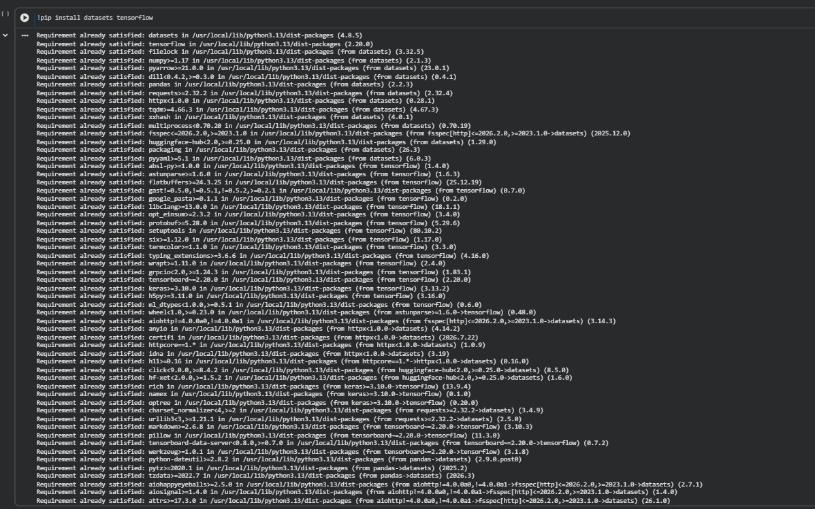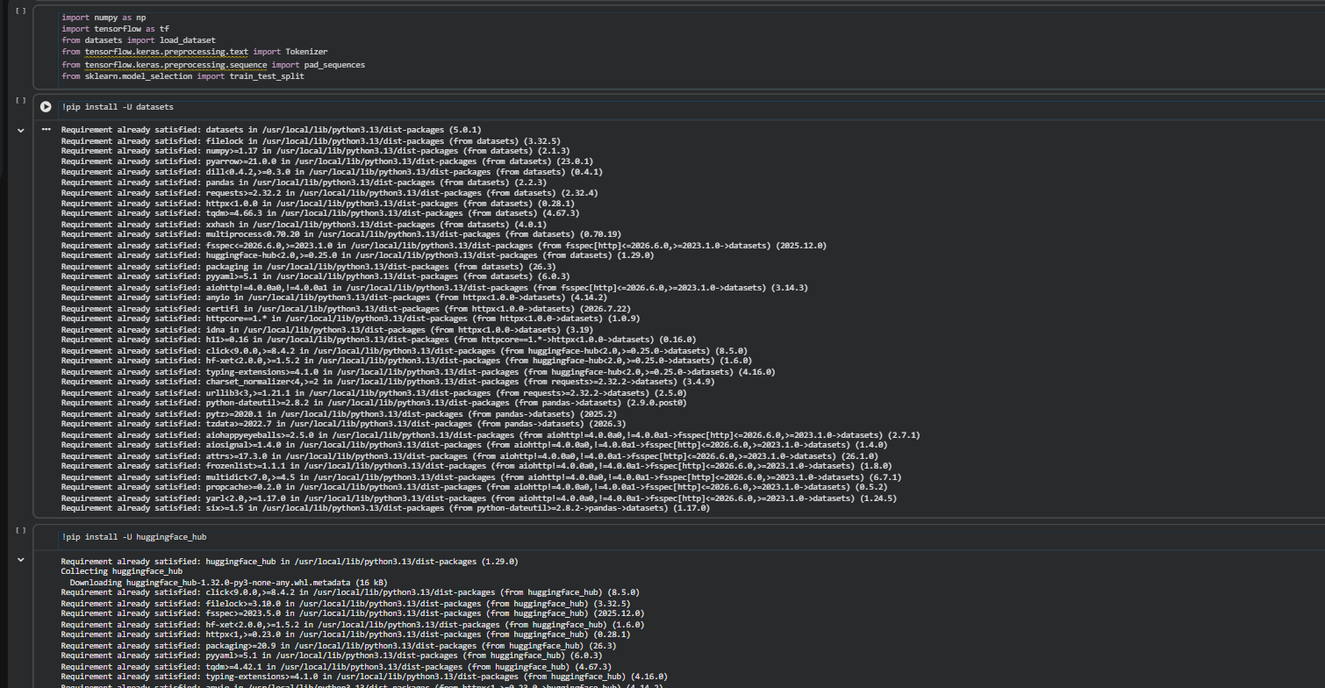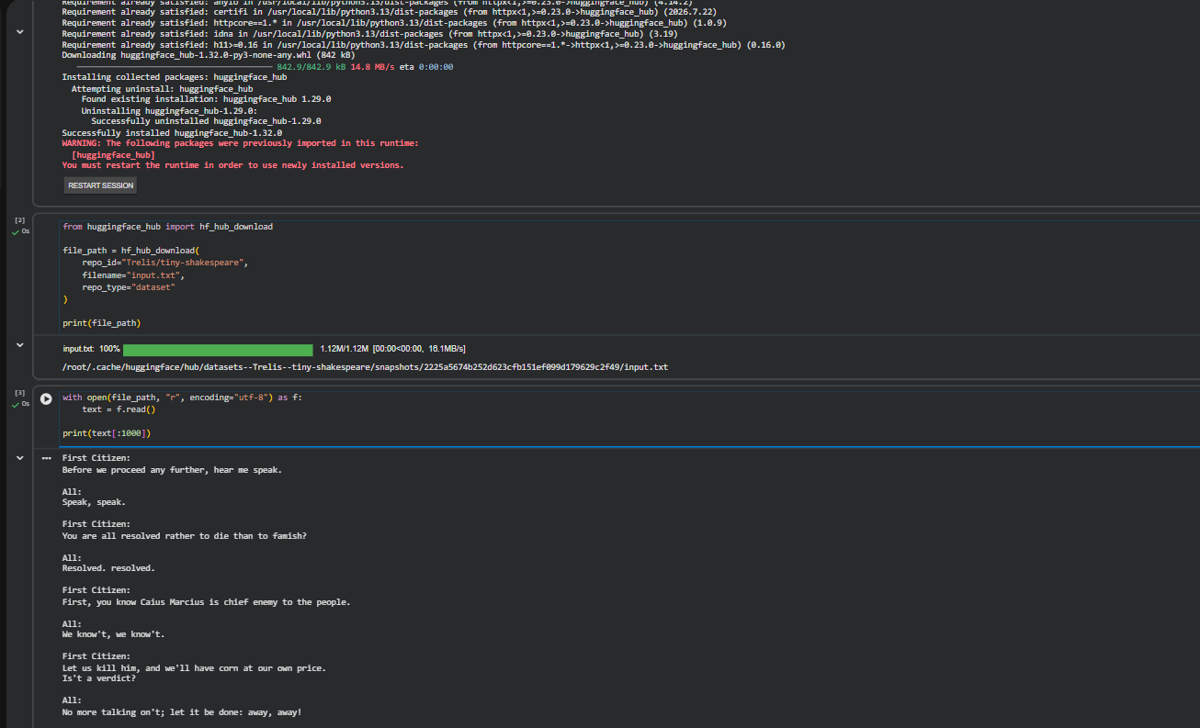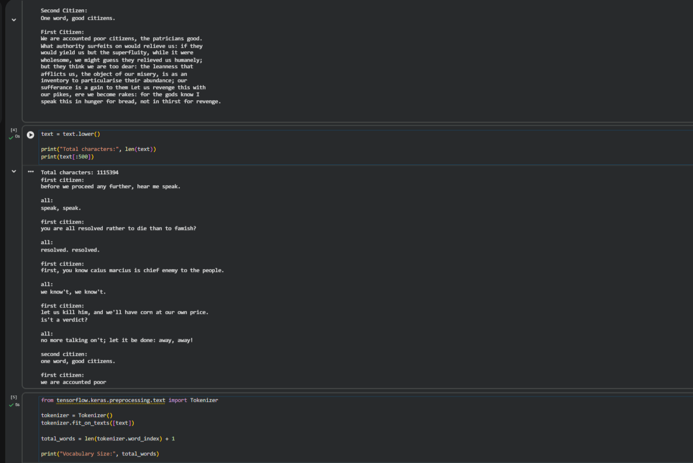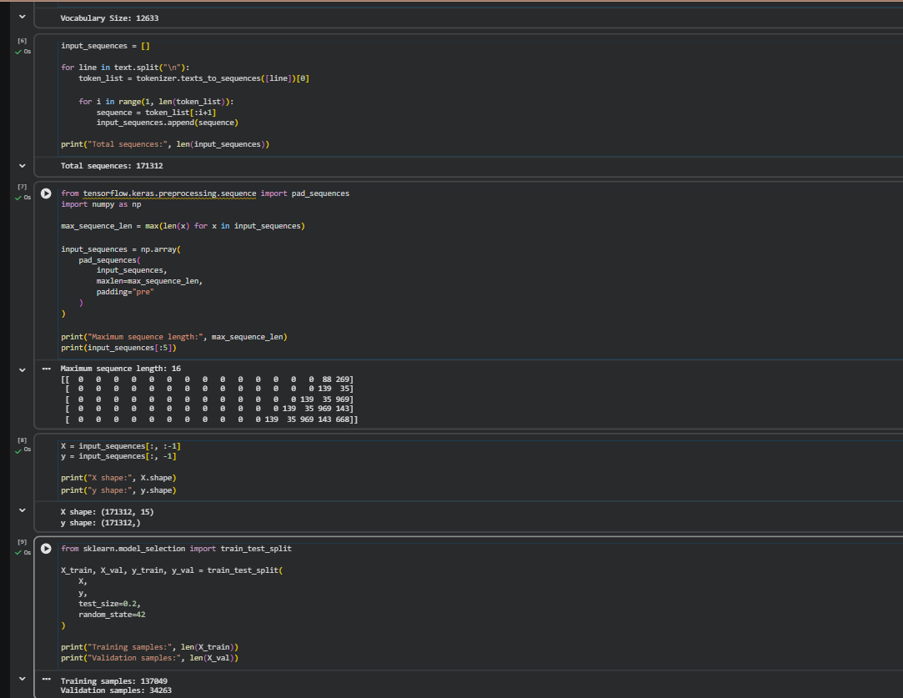TASK B: IMPLEMENTING THE RNN MODEL
Perform the following tasks:
- Create an Embedding layer to convert words into dense vector representations.
- Add a Simple RNN layer to learn sequential dependencies in the text.
- Add a Dense output layer with Softmax activation for next-word prediction.
- Compile the model using an appropriate optimizer and loss function.
- Display the model architecture and summary.

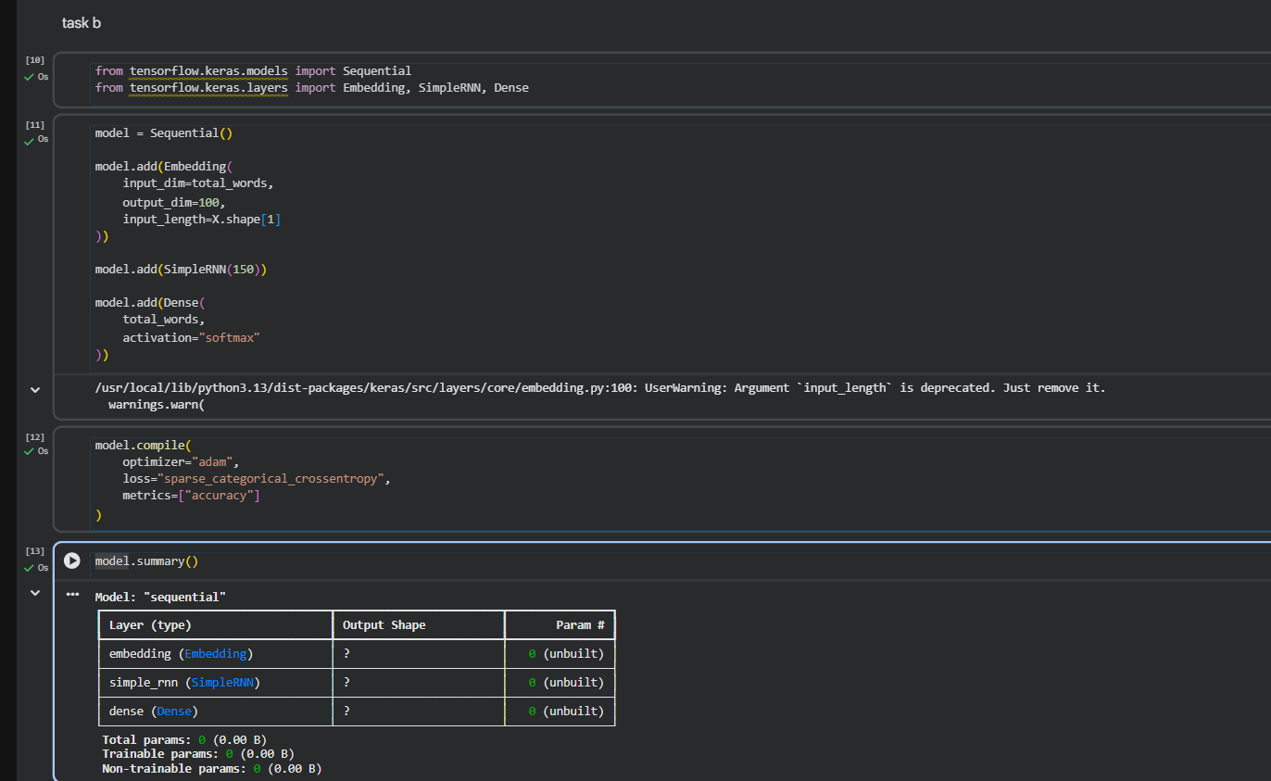TASK C: RNN MODEL TRAINING AND PERFORMANCE EVALUATION
Perform the following tasks:
- Train the RNN model using the prepared training dataset.
- Validate the model using the validation dataset.
- Record:
  - Training accuracy
  - Validation accuracy
  - Training loss
  - Validation loss
- Visualize:
  - Accuracy vs. Epoch
  - Loss vs. Epoch

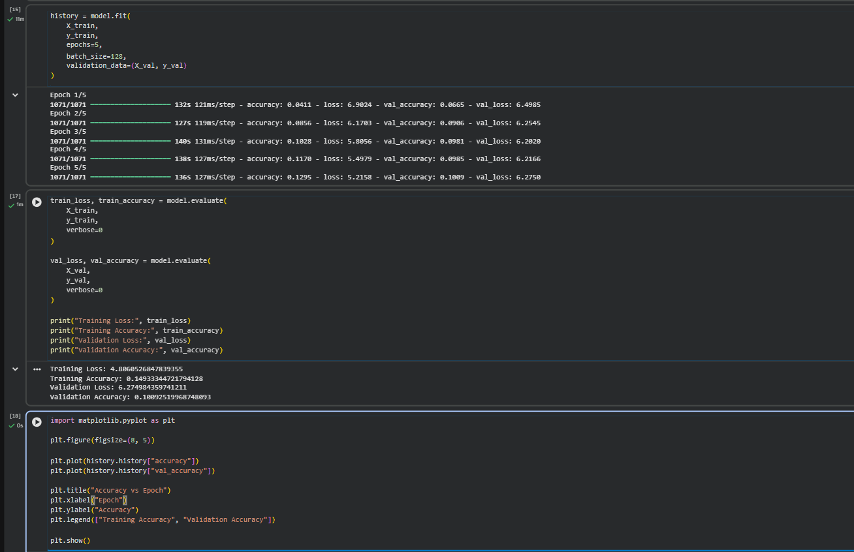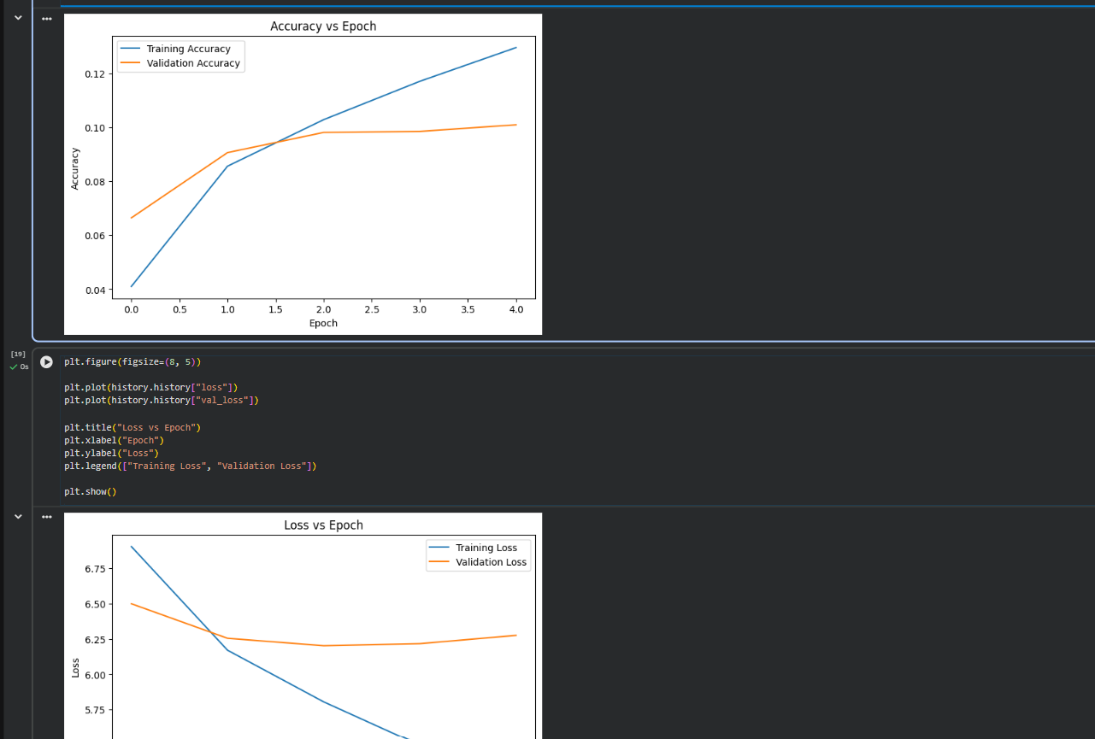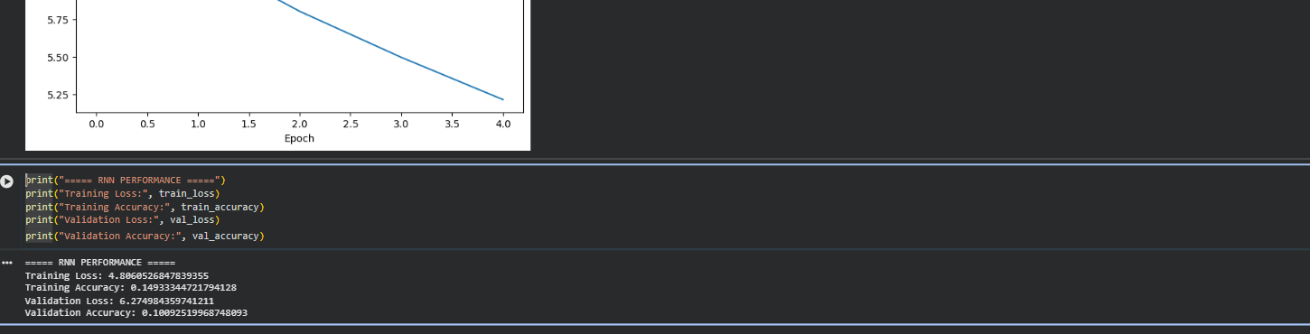
TASK D: DEEP LEARNING EXPERIMENT MANAGEMENT
Perform the following tasks:
- Provide a seed word or sentence as input to the trained model.
- Generate text by repeatedly predicting the next word in the sequence.
- Produce multiple text samples using different seed inputs.
- Compare the generated text for coherence and contextual relevance.
- Document the observations and upload the notebook to GitHub.

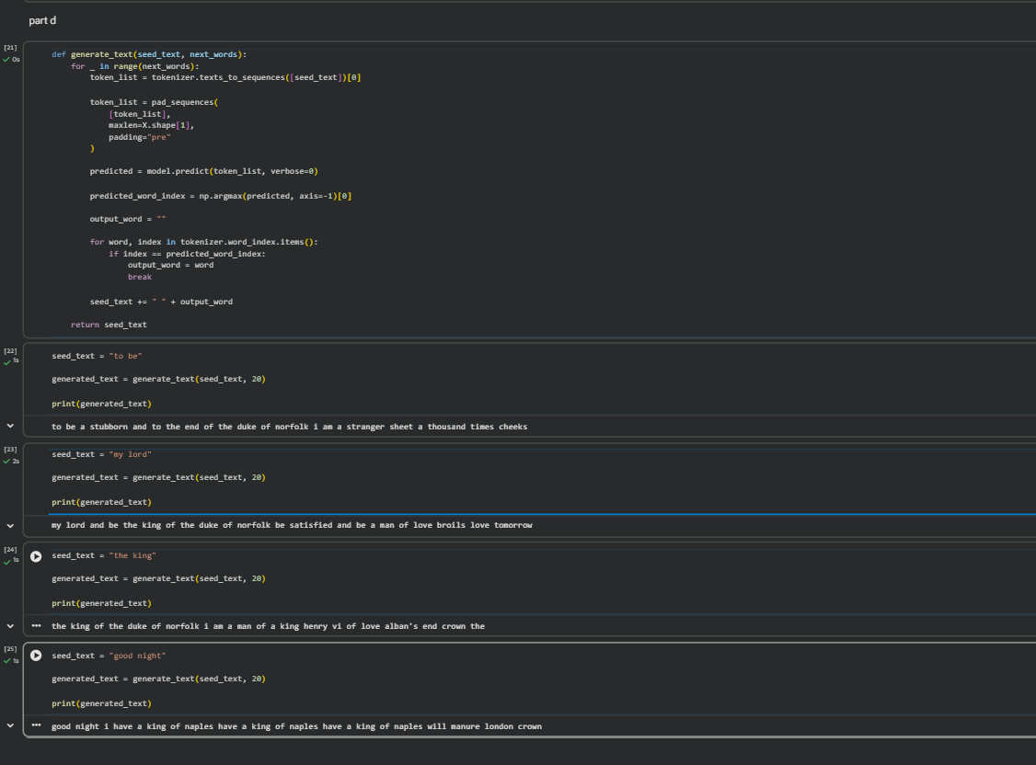

POST-LAB QUESTIONS (PROVIDE BRIEF ANSWERS TO THE FOLLOWING QUESTIONS)

1. Describe the role of the hidden state in an RNN during sequence processing.
The hidden state stores information from previous time steps. It helps the RNN remember earlier words while processing the current word.
2. Discuss the effect of training an RNN model for an insufficient number of epochs.
If the model is trained for too few epochs, it may not learn enough patterns from the text. This can result in poor text generation and low accuracy.
3. Explain the purpose of padding when preparing text sequences for RNN training.
Padding makes all input sequences the same length. This allows the sequences to be processed together by the RNN.
4. Discuss one limitation of a Simple RNN when processing long text sequences.
A Simple RNN may have difficulty remembering information from long sequences due to the vanishing gradient problem.
5. Discuss the effect of sequence length on the performance of the text generation model.
Sequence length determines how much previous text the model can use for prediction. Longer sequences provide more context but may increase training time.

ASSESSMENT
Description | Max Marks | Marks Awarded
Pre Lab Exercise | 5
In Lab Exercise | 10
Post Lab Exercise | 5
Viva | 10
Total | 30
Faculty Signature

